**SQL Case Study 4: Texture Tales**

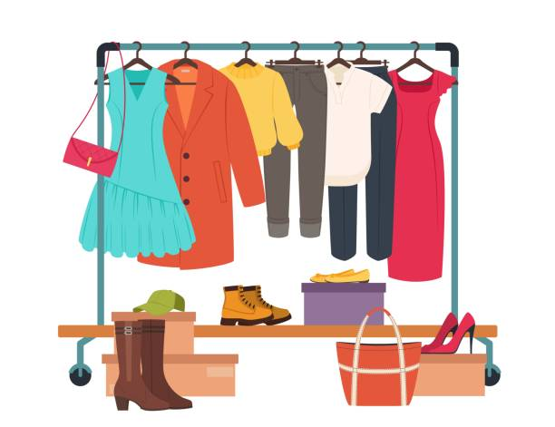

**INTRODUCTION:**

Texture Tales Clothing Company prides themselves on providing an optimized range of clothing and lifestyle wear for the modern adventurer!

I, the CEO of this trendy fashion company is asking you to assist the team’s merchandising teams analyze their sales performance and generate a basic financial report to share with the wider business.

**SCHEMA USED**

|  |  |
| --- | --- |
| product_details | |
| product_id | varchar |
| price | int |
| product_name | varchar |
| category_id | int |
| segment_id | int |
| style_id | int |
| category_name | varchar |
| segment_name | varchar |
| style_name | varchar |

|  |  |  |
| --- | --- | --- |
| sales | | |
| prod_id | varchar |
| qty | | int |
| price | | int |
| discount | | int |
| member | | varchar |
| txn_id | | varchar |
| start_txn_time | | varchar |

|  |  |
| --- | --- |
| Product_hierarchy | |
| id | int |
| product_id | int |
| price | int |
| start_date | date |
| end_date | date |

|  |  |
| --- | --- |
| product_prices | |
| id | int |
| product_id | varchar |
| price | int |

**CASE STUDY QUESTIONS**

1. What was the total quantity sold for all products?
2. What is the total generated revenue for all products before discounts?
3. What was the total discount amount for all products?
4. How many unique transactions were there?
5. What are the average unique products purchased in each transaction?
6. What is the average discount value per transaction?
7. What is the average revenue for member transactions and non-member transactions?
8. What are the top 3 products by total revenue before discount?
9. What are the total quantity, revenue and discount for each segment?
10. What is the top selling product for each segment?
11. What are the total quantity, revenue and discount for each category?
12. What is the top selling product for each category?

**SOLUTION**

1. What was the total quantity sold for all products?

Select prod_id , SUM(qty) As 'Total Quantity Sold'

From sales

Group by prod_id

order by [Total Quantity Sold] Desc;

**[OR]**

SELECT

details.product_name,

SUM(sales.qty) AS sale_counts

FROM sales AS sales

INNER JOIN product_details AS details

ON sales.prod_id = details.product_id

GROUP BY details.product_name

ORDER BY sale_counts DESC;

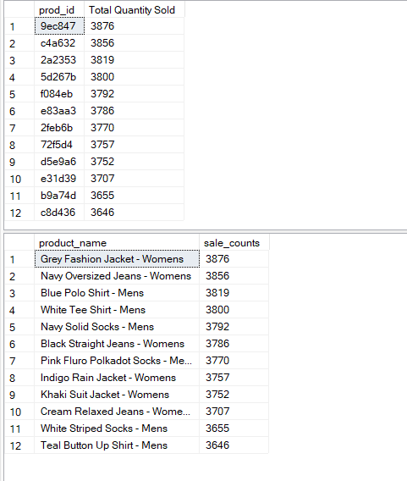

2.What is the total generated revenue for all products before discounts?

Select Sum(qty*price) as 'Total Revenue'

From sales;

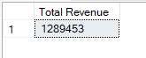

3.What was the total discount amount for all products?

SELECT

SUM(price * qty * discount)/100 AS total_discount

FROM sales;

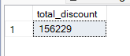

4. How many unique transactions were there?

Select count(distinct(txn_id)) as 'Unique Transactions'

from sales;

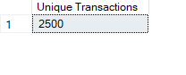

5. What are the average unique products purchased in each

transaction?

WITH cte_transaction_products AS (

SELECT

txn_id,

COUNT(DISTINCT prod_id) AS product_count

FROM sales

GROUP BY txn_id

)

SELECT

AVG(product_count) AS avg_unique_products

FROM cte_transaction_products;

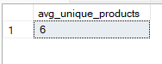

6. What is the average discount value per transaction?

WITH cte_transaction_discounts AS (

SELECT

txn_id,

SUM(price * qty * discount)/100 AS total_discount

FROM sales

GROUP BY txn_id

)

SELECT

ROUND(AVG(total_discount),2) AS avg_unique_products

FROM cte_transaction_discounts;



7. What is the average revenue for member transactions and non-

member transactions?

WITH cte_member_revenue AS (

SELECT

member,

txn_id,

SUM(price * qty) AS revenue

FROM sales

GROUP BY

member,

txn_id

)

SELECT

member,

ROUND(AVG(revenue), 2) AS avg_revenue

FROM cte_member_revenue

GROUP BY member;

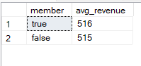

8. What are the top 3 products by total revenue before discount?

SELECT Top 3

details.product_name,

SUM(sales.qty * sales.price) AS nodis_revenue

FROM sales AS sales

INNER JOIN product_details AS details

ON sales.prod_id = details.product_id

GROUP BY details.product_name

ORDER BY nodis_revenue DESC;

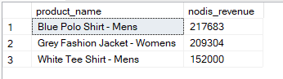

9. What are the total quantity, revenue and discount for each

segment?

SELECT

details.segment_id,

details.segment_name,

SUM(sales.qty) AS total_quantity,

SUM(sales.qty * sales.price) AS total_revenue,

SUM(sales.qty * sales.price * sales.discount)/100 AS total_discount

FROM sales AS sales

INNER JOIN product_details AS details

ON sales.prod_id = details.product_id

GROUP BY

details.segment_id,

details.segment_name

ORDER BY total_revenue DESC;

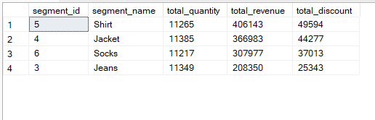

10. What is the top selling product for each segment?

SELECT Top 5

details.segment_id,

details.segment_name,

details.product_id,

details.product_name,

SUM(sales.qty) AS product_quantity

FROM sales AS sales

INNER JOIN product_details AS details

ON sales.prod_id = details.product_id

GROUP BY

details.segment_id,

details.segment_name,

details.product_id,

details.product_name

ORDER BY product_quantity DESC ;

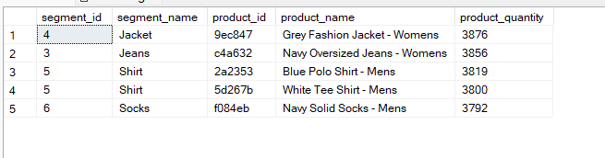

11. What are the total quantity, revenue and discount for each

category?

SELECT

details.category_id,

details.category_name,

SUM(sales.qty) AS total_quantity,

SUM(sales.qty * sales.price) AS total_revenue,

SUM(sales.qty * sales.price * sales.discount)/100 AS total_discount

FROM sales AS sales

INNER JOIN product_details AS details

ON sales.prod_id = details.product_id

GROUP BY

details.category_id,

details.category_name

ORDER BY total_revenue DESC;

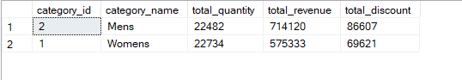

12. What is the top selling product for each category?

SELECT Top 5

details.category_id,

details.category_name,

details.product_id,

details.product_name,

SUM(sales.qty) AS product_quantity

FROM sales AS sales

INNER JOIN product_details AS details

ON sales.prod_id = details.product_id

GROUP BY

details.category_id , details.category_name , details.product_id , details.product_name

ORDER BY product_quantity DESC;

